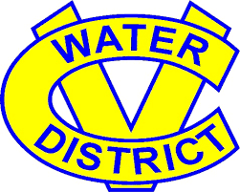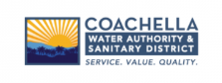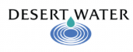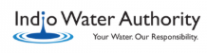

Water Year 2022 Indio Subbasin Annual Report
Workshop
AGENDA
March 16, 2023 at 10:00 am – 11:30 am
Online: Teams: http://bit.ly/3S5YRqf

or Dial In by Phone: +1 (951) 384-1050; Access Code: 617 193 974#

# | ITEM | TIME
1 | Welcome and Introductions  - GoToMeeting Instructions  - Agenda and Meeting Objectives | 10:00 am
2 | Annual Report Status  - Purpose and Objectives | 10:20 am
3 | Groundwater Elevation Data  - Monitoring Wells and Key Wells | 10:30 am
4 | Groundwater Extractions | 10:40 am
5 | Surface Water  - Local Surface Water, Imported Water, Recycled Water | 10:50 am
6 | Total Water Use | 10:55 am
7 | Plan Implementation Progress  - Plan Implementation Activities | 11:00 am
8 | Public Comment  - Your Participation and Input are Important | 11:10 am
*times are subject to change

